Exercise One Answers
Question 1: Pick any app you use daily (e.g., WhatsApp, Uber, YouTube, Jumia). List at least 5 things the backend must do when you perform a common action in that app. For example, what happens on the backend when you send a WhatsApp message?

- Authentication & Authorization.
- Message Encryption
- Database Storage
- Push Notification Trigger
- Delivery & Read Receipts

Question 2: A hospital wants to build a patient management system. What kind of data would the backend need to store? What business rules would you need to implement? Think about appointments, prescriptions, and billing.
- Patient Information (Full name, age, gender)
- Appointments (Patient ID and Doctor ID)
- Billing & Payments (Total bill amount)
Business Rules – control how data behaves
1. Appointment Rules - A doctor cannot have two appointments at the same time
2. Prescription Rules - Only licensed doctors can create prescriptions
3. Billing Rules - Every service must have a defined cost
Question 3: For each of the following features, identify whether it is a frontend or backend responsibility (or both):
- Displaying a user’s profile photo – Both
- Checking if a username is already taken during registration – Both
- Sending a password reset email – Backend
- Showing a loading spinner while data is being fetched – Frontend
- Calculating the total price of items in a shopping cart – Backend
- Encrypting a user’s password before storing it – Backend

Exercise 2: HTTP & APIs Answers
Question 1: For each action below, write which HTTP method (GET, POST, PUT, or DELETE) would be used
- Viewing your bank account balance – GET
- Creating a new social media account – POST
- Changing your profile picture – PUT
- Removing a product from your shopping cart – DELETE
- Searching for a book on an online store – GET
- Submitting a job application form – POST
- Updating your delivery address – PUT
- Unsubscribing from a mailing list- DELETE

Part B — Status Code Scenarios:
What HTTP status code would the server return in each scenario?
- You successfully log in to your account – 2OO Ok
- You try to access a page that has been removed - 404 Not Found
- You submit a form but forget to fill in required fields - 400 Bad Request
- The server crashes while processing your request - 500 Internal Error
- You try to view someone else’s private messages without being logged in - 401 Unauthorised
- You successfully register a new account – 201 Created

Part C — Write JSON: Write a JSON object for each of the following. Use proper JSON syntax with double quotes and correct data types:
- A book with title, author, year published, number of pages, and whether it is available
{
“title”: “Introduction to Algorithms”,
“author”: “Thomas H. Cormen”,
“year_published”: 2009,
“pages”: 1312,
“available”:true
}
- A student with name, registration number, course, year of study, and a list of 3 subjects
{
“name”: “Alvin David”,
“registration_number”: “24/U/11805/PS”,
“course”: “Computer Science”,
“year_of_study”: 2,
“subjects”: [
“Data Structures”,
“Machine Learning”,
“Artificial Intelligence”
]
}
- A mobile money transaction with sender phone number, receiver phone number, amount, currency, and timestamp
{
“sender_phone”: “+256758862363”,
“receiver_phone”: “+25678862363”,
“amount”: 5000,
“currency”: “UGX”,
timestamp”: “2026-04-15T10:30:00Z”
}

Exercise 3: Command Line Practice.
Part A — Getting Started (Basic):
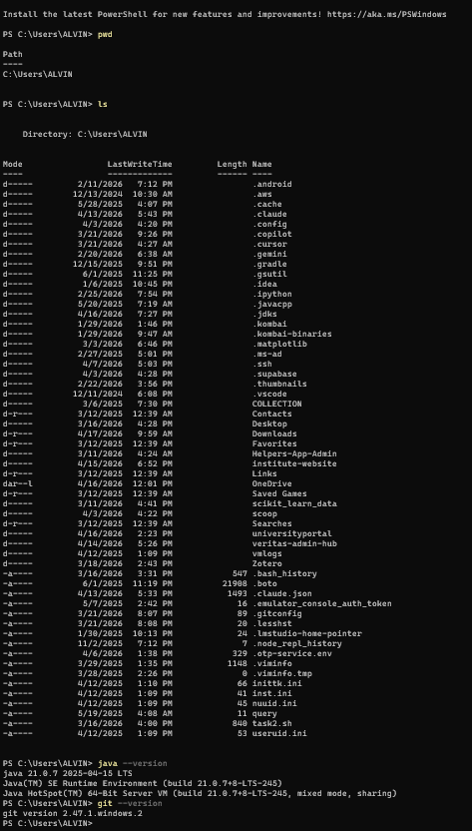

Part B — Build a Project Structure:
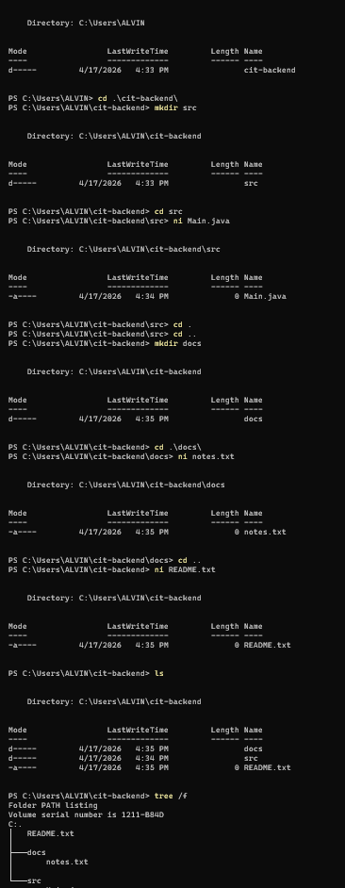
Part C — File Operations:
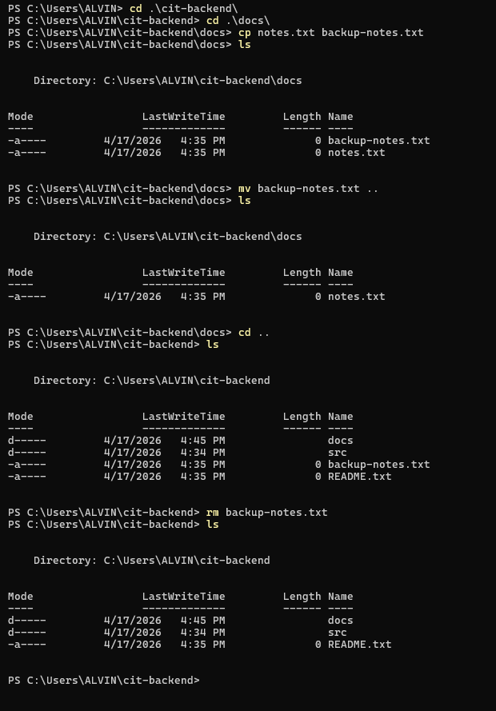
Exercise 4: Putting It All Together (Bonus Challenge)
List 5 types of data (resources) this system would need to manage (e.g., students, teachers, etc.)
- Students.
- Teachers.
- Courses.
- Classes.
- Grades.
For each resource, write a sample JSON object with at least 4 fields and appropriate data types
- Student

{
“id”: 1,
“name”: “Waluube Alvin David”,
“registration_no”: “24/U/11805/PS”,
“year_of_study”: 1
}

- Teacher
{
“id”: 101,
“name”: “Dr.Wakholi”,
“department”: “Computer Networks”,
“email”: peterwakholi@lecturer.mak.ac.ug
}

- Course

{
“id”: 502,
“course_name”: “Computer Networks”,
“course_code”: “CSC2001”,
“credits”: 4
}

- Class

{
“id”: 1000,
“student_Id”: 1,
“teacher_id”: 101,
“date”: “2026-04-20”,
“time”: “10:00”
}

- Grade
{
“id”: 3001,
“student_id”: 1,
“course_id”: 1000,
“score”: 78,
“grade”: “B”
}

Design 3 API endpoints for the “Students” resource. For each, specify the HTTP method, a descriptive URL path, and what it does. Example: GET /students — Retrieves a list of all students

- Get all students
Method: GET
URL: /students
Description: Retrieves a list of all students

- Create a new student
Method: POST
URL: /students
Description: Adds a new student to the system

- Get a single student by ID
Method: GET
URL: /students/{id}
Description: Retrieves details of a specific student

For each endpoint, what status code would be returned on success? What about on failure?

- GET /students
Success: 200 OK
Failure:
500 Internal Server Error (server issue)

- POST /students
Success: 201 Created
Failure:
400 Bad Request (invalid input) 409 Conflict (duplicate email, etc.)

- GET /students/{id}
Success: 200 OK
Failure:
404 Not Found (student does not exist)
500 Internal Server Error

Using the command line, create a project folder structure for EduTrack with folders for: src, docs, tests, and config. Create a README.txt file in the root.
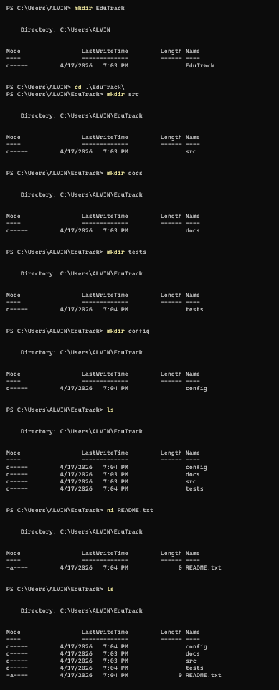
Research Questions
Look at JDK AND JRE (Features, Diff)
Process that a JAVA file undergoes.
Get to know more Methods of the HTTP.
Create a text file.
GET
👉 Used to retrieve data from a server
- Does NOT change anything on the server
- Most common method
Example:
GET /users
📌 Fetch all users

2. POST
👉 Used to send data to the server (usually to create something)
- Creates a new resource
Example:
POST /users
📌 Create a new user

3. PUT
👉 Used to update/replace an entire resource
- Sends full updated data
Example:
PUT /users/1
Replace user with ID 1 completely

4. PATCH
Used to partially update a resource
- Only sends fields you want to change
Example:
PATCH /users/1
Update just the email or name

5. DELETE
Used to remove a resource
Example:
DELETE /users/1
Delete user with ID 1

6. HEAD
Same as GET, but returns only headers (no body)
- Useful for checking:
  - if a resource exists
  - metadata (like content type, size)
Example:
HEAD /users

7. OPTIONS
Used to find out what methods are allowed
- Common in CORS issues (you’ve actually faced this)
Example:
OPTIONS /users
Server responds with allowed methods like:
GET, POST, PUT

8. TRACE
Used for debugging
- Echoes back the request
- Rarely used in production (security concerns)

9. CONNECT
Used to establish a tunnel
- Mostly for HTTPS via proxies
- Not common in everyday app development

